Weight Training Study Guide
Safety
- Safety is our number one concern. Do not fool around. It is very easy for someone to drop a weight on someone that is not paying attention. Pay attention to your surroundings.
- Always warm-up before beginning your weight lifting workout.
- Never work the same muscle two days in a row.
- Always use a spotter when lifting weights of any kind of bar.
- “Lifter” should signal spotter before beginning to lift.
- Do not hold your breath when lifting.
- Always secure the clips when adding weights to a bar.
- Always put weights away.
General Information
- Toning muscle – lift lighter weights with more repetitions (2 sets of 15 or 3 sets of 12)
- Increasing strength – lift heavier weights with fewer repetitions (3 sets of 8 or 3 sets of 10)
- When using free weights do sets of 8-12 repetitions. If you cannot do 8 repetitions, the weight is too heavy. If you do not tire after 12, the weight is too light.
- Weight machines – raise and lower the weight on the count of two.
- Maximum Heart Rate (MHR) is figured by subtracting your age from 220. (220 – age = MHR)
- When using cardiovascular equipment, a person your age should get their heart rate up to 140-180 beats per minute (BPM) for approximately 20 minutes in order for it to be considered an aerobic workout. 65%-80% of your MHR.
- It is safe for both boys and girls to weight train.
- Feet should be about shoulder-width apart when doing squats.
Benefits of Physical Activity and Exercise

- Reduces risk of heart disease
- Decreases cholesterol levels
- Slows aging process
- Improves and maintains mental health
- Decreases stress
- Prevents and controls diabetes
- Reduces risk of osteoporosis

- Decreases hypertension and high blood pressure
- Helps shed excess pounds
- Improves self confidence
- Prevents common cold and flu
- Relieves back pain
- Improves arthritis
- Improves the quality of the air you breathe

Five Components of Fitness
- Muscular Strength - Measure of the greatest force that can be produced by a muscle or group of muscles.

- Muscular Endurance – The ability to contract a muscle or group of muscles repeatedly without incurring fatigue. (Participate in activity without getting tired.)

- Cardiovascular Fitness – Ability of the heart and lungs to supply oxygen to the working muscles for an extended period of time.

- Flexibility – Ability of a joint to move freely in every direction, or more specifically, through a full and normal range of motion.

- Body Composition – Refers to the quality of makeup of total body mass (TBM). TBM is made up of the lean body mass (bones, muscles, organs and water) and fat mass.

Principles of FITT
When designing a workout plan, you should follow the FITT principle for improving and maintaining physical fitness.
FREQUENCY – How often do you exercise? For beginners, consider starting with 2-3 sessions per week and gradually move up to 3-5 times a week.
INTENSITY – How hard do you exercise? For example, the pace you walk or run, the amount of weight you lift, or your heart rate count.
TIME – How long do you perform an activity? “Time” can also refer to the number of sets of repetitions you perform in weight training.
TYPE – What type of exercise is selected? It is based on the principle of specificity. (Based on the five components of fitness.)

Principles of Training
Specificity – The activity performed must be specific to the desired effect. An example, muscle strength training may not lead to flexibility; flexibility training may not help cardiovascular endurance. Also, each area of the body must be worked on specifically strength, endurance, and flexibility. However, it is possible to design a program that improves more than one aspect at a time.
Overload – In order to improve in any area of fitness, the workload must be greater than that to which the individual is accustomed.
Progression – The overload should be gradual and moderate within minimum and maximum limits to prevent soreness and injury.
Reversibility – “If you don’t use it, you will lose it.” With no training, the effects of training will be lost. This is called atrophy.
Why Lift Weights?
Weight training helps keep you and your bones strong. Another bonus? The muscle you build helps burn more calories, even when you are doing absolutely nothing or sleeping. Muscle is like a “car engine.” It burns gas, or calories, and provides the power your body needs to fuel you to get from place to place. The bigger the “muscle engine” the more calories you will burn at work and at rest. It is possible to increase your metabolic rate by at least 7 percent after a six month intense training regimen. This means if you are eating 2000 calories a day, you would burn an additional 140 calories each day. At this rate, you would lose over seven pounds of fat in six months.
Why Should I Strength Train?
- Lean muscle tissue is simply muscle and it is critically important to your metabolism because it is the body’s most active tissue. So, by increasing the amount o muscle in your body, you are forcing your body to be a big calorie spender. How can you increase your lean muscle tissue? ONLY THROUGH STRENGTH AND RESISTANCE TRAINING!
- By creating resistance through the use of free weights, weight training machines, elastic tubing, or your body weight, a muscle is challenged to perform an activity beyond its current strength. Challenging a muscle to grow stimulates a muscle to grow, producing more lean muscle tissue.
- So, if you lose muscle, diminish your basal metabolic rate and keep eating the same amount of calories. Then, those additional calories will be stored as body fat. Your goal should be to burn fat by eating a balanced diet, burn the fat, and build lean muscle tissue. The fat is not turning into muscle. It is being eliminated. The fat burning and lean muscle building are two separate processes.

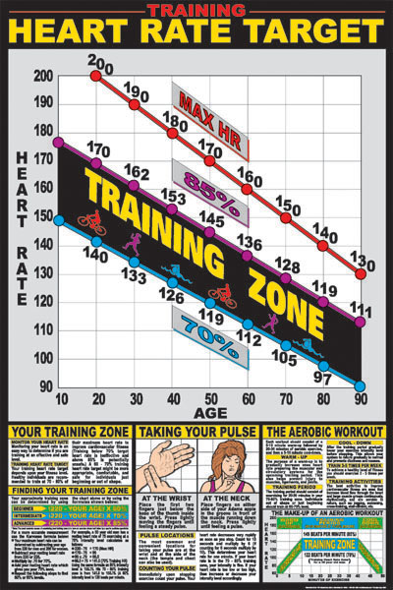

ESTIMATED MAX HEART RATE:
To establish your estimated max heart rate, use this formula. Max Heart rate = (220 – Age).
Example: 28 year old person
(220 – 28 = 192 beats per minute)
TARGET HEART RATE:
The minimum heart rate and duration of exercise needed to develop endurance. The average minimum training heart rate is 65% of your max heart rate. The duration of this should be a minimum of 20 minutes; this time does not include your warm-up time!

