SOCCER STUDY GUIDE

OBJECTIVE

The objective of soccer is to score more goals than the opposing team and to defend your team’s goal. The game is started with a kick-off, and at the end of two 45 minute halves, the team with the higher number of goals wins. Each team has 11 players. The attacking team is the team in possession of the ball or said to be the offensive team. The defending team is the team without the ball.
Players move the ball down the field by dribbling or passing. Dribbling consists of a series of short taps with the feet. After a goal is scored, the team that did not score gets to kick-off in the center circle.

FIELD/BOUNDARIES

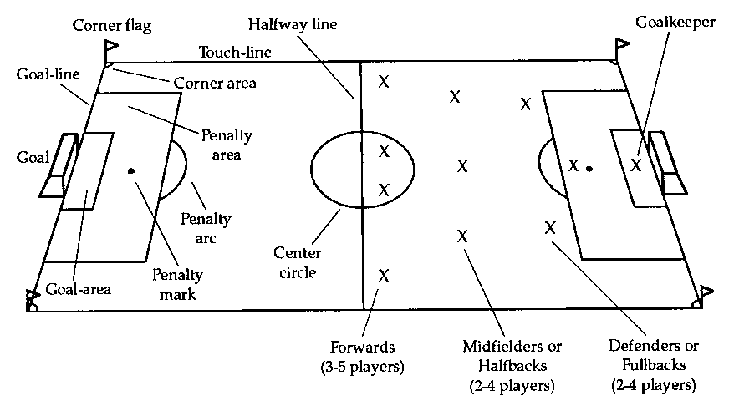

VOCABULARY

Throw-in – A way to restart play when the ball goes out over the sidelines. The team that did not touch the ball last is allowed an overhead throw. Both feet must be on the ground, two hands have to be used and the ball must be thrown overhead for a throw-in to be legal.

Corner kick – If the defensive team kicks it out at the endline, play is restarted with a corner kick by the offense.

Goal Kick – If the offensive team kicks it out at the endline, play is restarted with a goal kick by the defense. The kick is taken by any defensive player from inside the goal area/box.

Direct Free Kick – A type of "free kick" given after severe fouls such as hitting or kicking. On a direct kick, a goal can be scored by kicking the ball into the goal without it first touching another player.

Indirect Free Kick – A type of "free kick" given after minor fouls such as obstruction. On an indirect kick, another player (on either team) must touch the ball before a goal can be scored.

Foul – When the referee judges a violation against an opposing player. The team that suffers the foul is awarded with a direct free kick unless the foul is committed by a defensive player inside his own penalty area, in which case the foul results in a penalty kick.

Offside – A violation that occurs when an offensive player is closer to the opponent’s goal than both the ball and the second-to-last opposing player at the time that the ball is passed to the offensive player by his or her teammate. Players cannot be called offside if they are in their own half of the field or if they receive the ball from a throw in, corner kick, or goal kick. When a player is called offside, the opposing team is awarded an indirect free kick.

Penalty kick – A kick taken from 12 yards in front of the goal as a result of a contact foul or hand ball that takes place inside the penalty area.

Red card – A referee shows a player a red card to signal that the player has been banned from the rest of the match. A red card can be shown for a single serious offense or as the result of being shown a second yellow card in the same game. After a player is shown a red card, the player must leave the field of play and cannot be replaced by a substitute, meaning that his or her team must finish the match with one player fewer.

Caution/yellow card – A disciplinary action in which the referee shows a player the yellow card (for violating a soccer rule, obviously). A second caution in the same match results in the player being shown the red card (ejected from the game).

Drop ball – Method of initiating play when a specific rule has not been violated or a double personal foul has resulted.

Trapping – Is the skill of receiving the soccer ball. Sometimes a received ball is literally trapped under the foot and sometimes it is received in way that advantageous. This term is diminishing and being replaced with “receiving.”

Tackling – A term used for stealing the soccer ball from the opponent. Body contact should be avoided.

Trajectory – The pathway an object travels.

RULES

- No hands (fingertips to the top of shoulder). When hands are used the call made is a “hand ball.”
- A kick-off is the way to start and re-start a soccer game. Kick-offs happen at the start of the game, after a goal is scored, at the start of each period and at the start of each overtime period. There is a coin toss before the start of the game. The winner of the toss gets to choose which goal it will attack and the other team takes the kick-off. At each kick off, the ball is placed in the center of the "Center Mark" (on the half-way line) & both teams must be on their own half of the field & the receiving team must stay outside the center circle until the ball is "kicked". Moving the ball any constitutes a "kick off", even if it only goes an inch. However, the ball must move forward on the "kick off".
- Direct and indirect kicks are two primary ways that play is restarted after the referee stops play for an infraction. For both of these the ball must be stationary before it is kicked and the opposing players should be a minimum of 10 yards away. An indirect kick must be touched by another player before it can go into the goal – that is the kicker and a second person.
- A penalty kick results from a contact foul or hand ball by the defending team within the penalty area – the large box on either end of the field. So it’s a type of direct kick also. The ball is placed on the penalty spot or mark, 12 yards in front of the center of the goal. All players must remain outside the penalty area and the penalty arc until the ball is kicked. The goalkeeper must have both feet on the goal line until the ball is kicked
- A player cannot touch the ball twice in a row when putting the ball in play.
- The common rule of thumb on fouls is “If it looks like a foul, it probably is.” Too true. A player cannot kick, trip, jump at, charge, strike, push, hold, or spit at an opponent.

PLAYER POSITIONS

Goalkeeper – The Goalie's job is to defend his team's goal and he usually stays close to his goal. You can identify the Goalie because he wears a different colored shirt or a vest over his shirt. As long as he is in the "Penalty Box" he can use his hands to pick up the ball, but if he comes out of the Penalty Box he cannot use his hands.

Midfielders – The Midfielders play between the Fullbacks and the Forwards. There can be "Offensive Midfielders" who play closer to the Forwards and "Defensive Midfielders" who play closer to the Fullbacks, as below.

Forwards – Forwards play closer to the opponent's goal, which is the goal guarded by the opposing Goalie. The Forwards are the primary scorers, although Midfielders sometimes score and at older ages Fullbacks even occasionally score.

Defenders – The defenders job is to protect the goal; stop the opponents from scoring.

BASIC SKILLS

Dribbling – one way that players move the ball on the field by tapping the ball with the inside, outside and top of the foot. Ball should be kept under the players body while moving. Principles to follow when dribbling include: dribble into open spaces, create passing angles, attract opponents, change direction and/or speed to beat opponents.

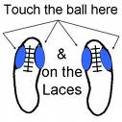

Passing – most commonly, the inside of foot “push” pass is used.
- Square-up to target
- Place plant foot approximately 4 inches from the ball (centered or a little towards the back of the ball)
- Plant foot points in the direction of the target
- Head over the ball looking down
- Knees bent

- Striking leg swings backwards and forwards
- Striking foot contacts the center of ball

- Follow-through towards target

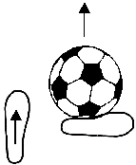

Shooting

- Head down – eye on the ball. You have to look up to pick out your target and then look back to the football as they actually shoot. This is because it is virtually impossible to strike the ball correctly if you're not looking at it.
- Plant non-striking foot along side the ball. Helps to keep ball trajectory low and straight.

- Keep the knee of the kicking leg over the ball. This technique determines the correct body position. Often, students will be standing too far behind the ball when they shoot. This results in too little power.

- Approach the ball slightly from the side.
- Contact ball with instep or top of foot.
- Strike the middle of the ball.

- Follow through. Kick continues towards target.

