Lacrosse Study Guide
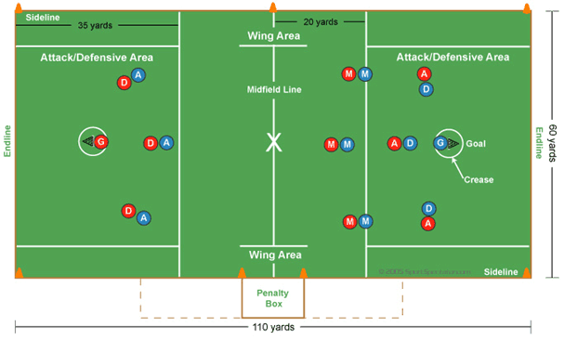
Lacrosse is played on a large rectangular grass field. The field has markings with specific functions:
Midfield line: Divides the field into equal halves. The X centered on this line is where face-offs take place. Also, the proper number of players on each team must remain on each half of the field to avoid being called for offsides.
Sidelines and endlines: Mark the boundaries. When a ball or player goes out of bounds, the opposing team takes possession. Following a shot, the player closest to spot where the ball went out of bounds has possession. Therefore, a teammate should always be in a position to back up a shot.
Goal: Points are scored when the ball passes through this six-foot by six-foot square.
Crease: Circle surrounding the goal that the offense cannot enter. Players can reach into the crease with their stick to gain possession of a loose ball, but cannot touch the goalie. Crease violations result in a penalty.
Attack area/defense clearing area: The offense has 10 seconds to move into this area after crossing the midfield line. Once the defense has possession of the ball, it has 10 seconds to advance out of this area. Also, attackers and defenders must remain in these areas during the face-off.
Penalty box: Used as a holding area for players to wait out their penalties. It is also the access area for substitute players entering and exiting the field for on-the-fly substitutions.
Wing area: Two of the three midfielders must remain in the wing area until the face-off starts.
Positions
Two teams compete with 10 players on the field. Players fall into four categories:
Attack: Offensive-minded players who possess great stick skills that allow them to shoot with precision and fake. They use speed and agility to elude defenders. Attackers also endure punishing hits from opponents.
Midfield: Always on the move, these players advance the ball up the field and play both offense and defense. Help defenders and tally assists by taking the ball from defensive area to attackers. They are fast, durable, and stick savvy. Also called “middies.”
Defense: Defenders use size, speed, strength, and skill to keep attackers from scoring. An aggressive mindset is beneficial, but playing under control and selecting the proper angle to prevent close range shots are more critical skills.
Goalie: Uses lightning-fast reflexes, quick decisions, and courage to stop a barrage of high-velocity shots. Body must handle punishment from the ball, and mind has to quickly recover from mistakes. The goalie directs the defense by calling for checks and relaying locations of the ball and attackers.

